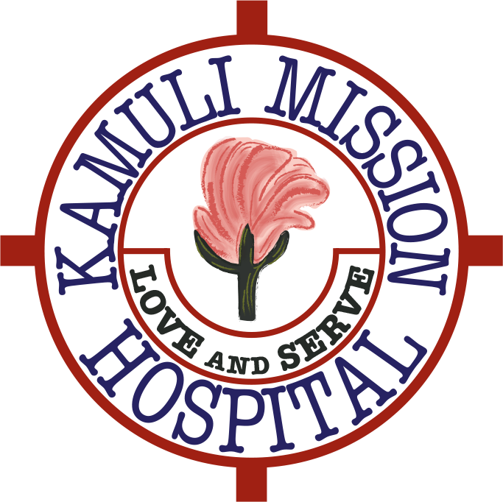KamuliFriends Newsletter   
December 2017

*Dear Friends and Supporters*

Welcome to our 2017 newsletter.

At the end of November Philip Unwin and Fred Lohmander made their annual two week visit to Kamuli Mission Hospital. Whilst out there Philip provided the below update on the current project we have embarked on.

“As you may remember we are rebuilding the Medical Ward here at Kamuli. It desperately needed doing, the old one was crawling with termites and bats !

As you can see from the photos below the new ward is truly splendid in comparison and everyone here is so grateful to you all.

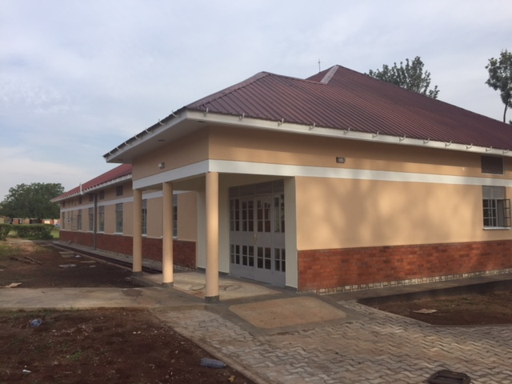

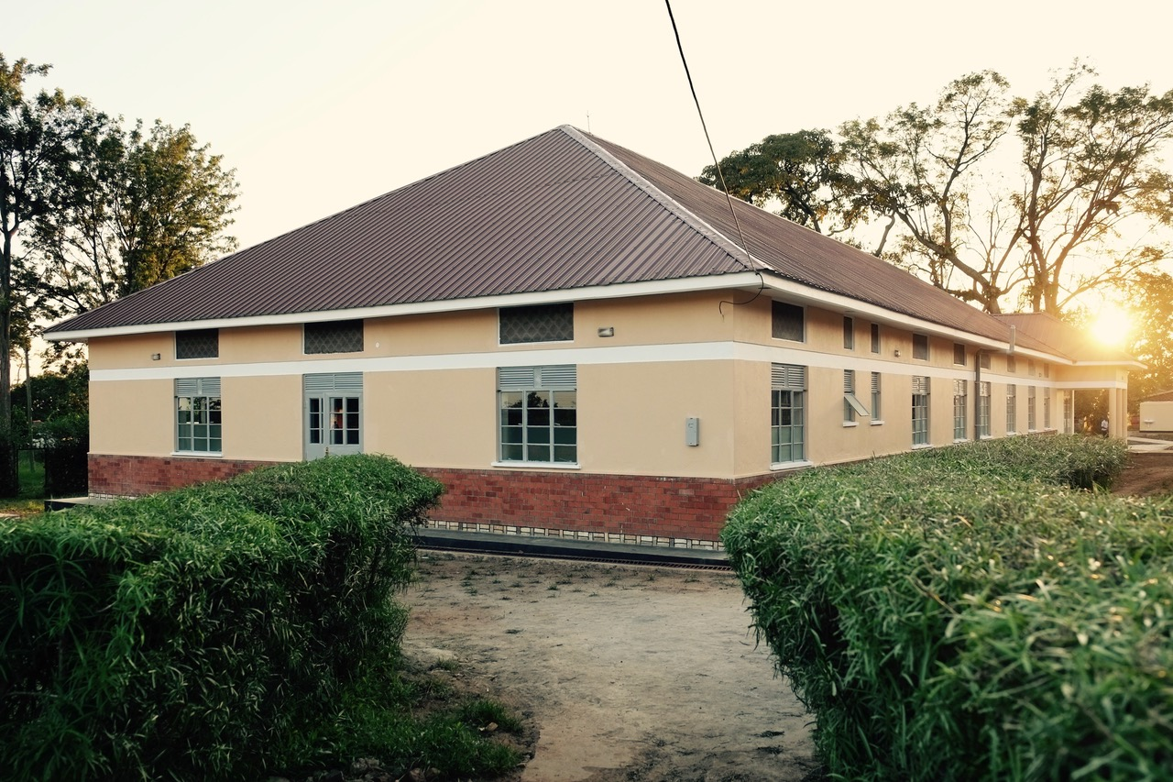

The main construction work is now complete and they are preparing a grand opening next week which will be utterly cringe-worthy with speeches and singing. I have no doubt I will be asked to say a few words and will try to mention you all by name.

The current challenge is to kit the ward out with beds and equipment which is expensive so I have been rooting around in all the old sheds unearthing old beds, screens, drip-stands and trolleys. Andrew, the maintenance man, and I are on a mission to take them all apart and have them repainted and refurbished. It means we make a massive saving and will please our Trustees as they have to watch every penny spent!

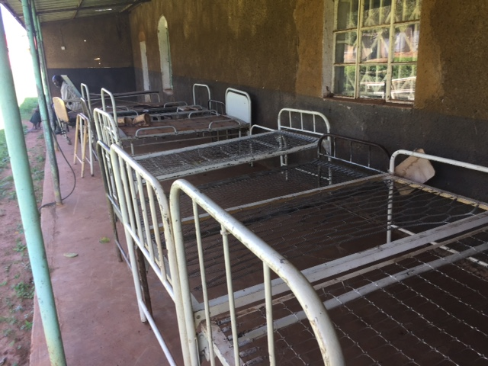

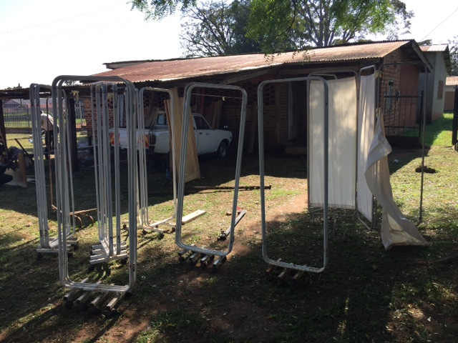

It is good to give the locals the work and they are all trying to give us good prices and get the work done ...well that's what they say!

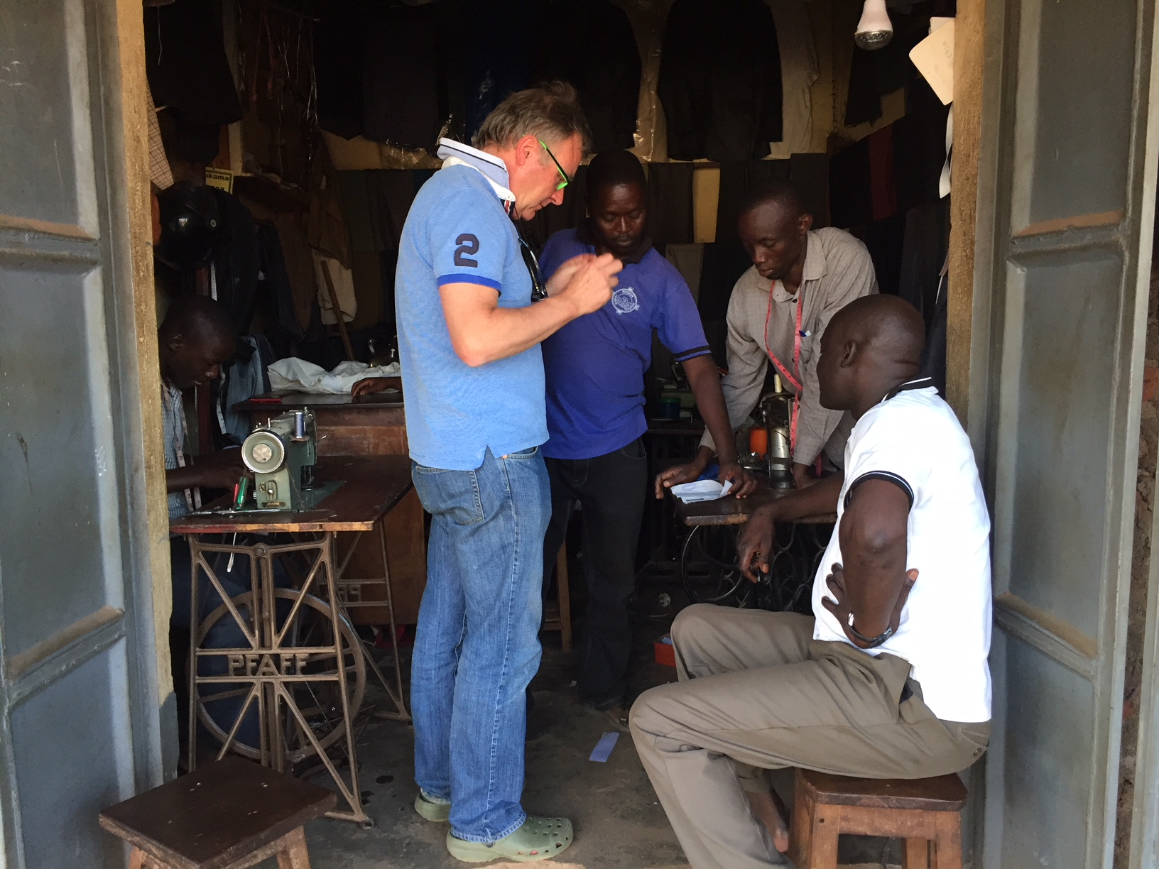

The other shock is there are plans to connect the new ward to the rest of the hospital with a covered walk way which will cost an extra £10k. The builder assures me he is only charging for the materials. It makes sense but it's an extra that we hadn't budgeted for.

The work here continues relentlessly. We are currently doing several Caesarean sections a day. Fred and I are just off to do another one ...

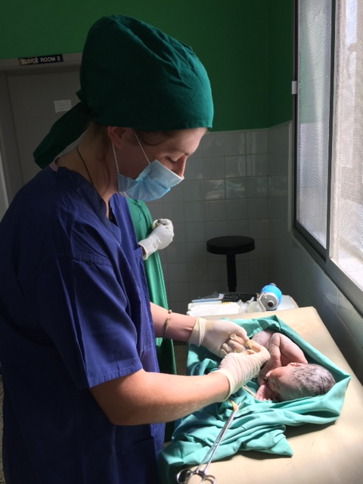

We are here at the moment with a student nurse, Joanna, from Henley and two 5th year medical students from Holland who have been here over a month. The guest house is constantly in use with visiting medics from all over the world, which is great and largely thanks to Alice (get well soon) who is now an obstetric registrar in Liverpool. Everyone is so grateful for the improved accommodation which makes life tolerable. Next week we are hosting a fistula camp for all the women suffering after childbirth so that will be interesting and is now becoming a regular event.

Thank you all for your continuing support. it is very much appreciated and if anyone fancies a trip you would be made very welcome, though I appreciate that it’s not for everyone.”

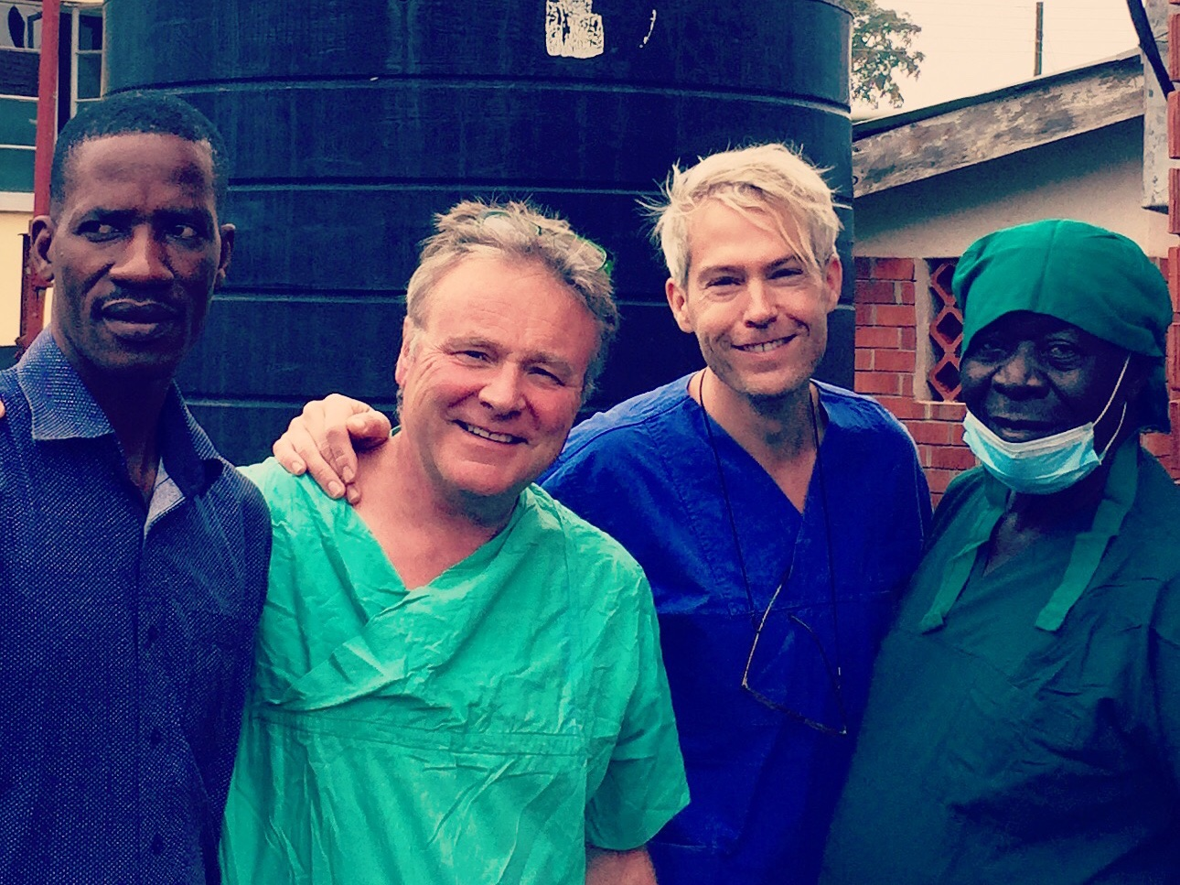

*Philip, Fred, and two Kamuli Mission Hospital staff*

**Funds raised and use of Funds During 2017**

Even though we have not held any major fund raising events during 2017 we have had donations of over £110,000 during 2017. £100,000 of this was from one very generous benefactor and the remaining through other individual donation, groups who have very kindly made generous donations after hearing Philip give an update of what we are trying to achieve and also from people in Sweden who have heard about KamuliFriends through Fred.

Further as mentioned in last year’s newsletter after a lot of thought and due diligence the Trustees felt it was not a good use of funds to continue with the Ambulance Project.  The logistics of running and maintaining was the stumbling block and they did not feel that making a large capital outlay for a vehicle which may not be used because there was no one to maintain it or coordinate the use of it may have meant it would just sit there and not be used to its full potential.  In our last newsletter we asked everyone if there were any objections and none were received.  We decided therefore to divert those funds to help with the funding of the rebuild of the Medical Ward and we hope you will all agree it has clearly been worth it.

**Other News**

At the beginning of 2017 Kamuli District suffered a drought. This had a massive impact of families as their crops suffered and they were not able to raise funds by selling them. This left a lot of families hungry and without food. During this period two volunteer doctors who were introduced to the hospital via the KamuliFriends volunteer programme, Joe Rylands and Imogen Hay, decided to raise funds to give to needy families. They did this using the KamuliFriends Just Giving platform and raised nearly £900 which they distributed to the neediest families.

**Trustee News**

Unfortunately Steve Miller has had to resign as a Trustee due to his other work and family commitments. We needed a lot of Trustee input this year due to the new Medical Ward build and Steve felt he could not commit to the time needed for this. We would like to thank Steve for all the work he has done helping to set up the charity and putting the guidelines and infrastructure in place.

If you would like to know more about KamuliFriends visit our website [www.kamulifriends.com](http://www.kamulifriends.com/) or follow us on Instagram KamuliFriends.

With all best wishes for a happy and healthy 2017.

Philip, Fred, Alice, Helen, Trevor and Trudie

**KamuliFriends**

[**http://www.kamulifriends.com/**](http://www.kamulifriends.com/)

**Registered Charity No1155812**

**Just Giving link (**[**http://www.kamulifriends.com/donate/**](http://www.kamulifriends.com/donate/)**) click** [**here**](http://www.kamulifriends.com/donate/)