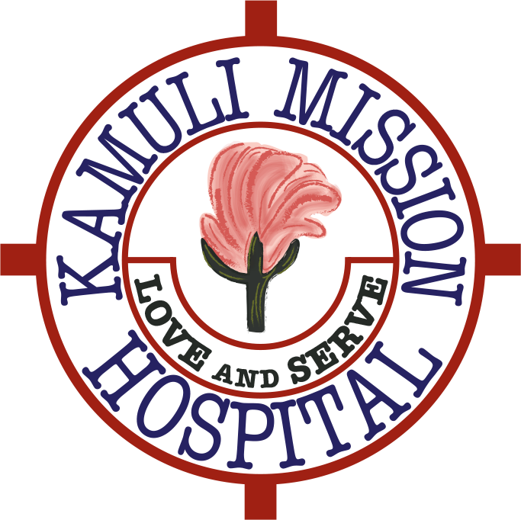
KamuliFriends Newsletter
December 2016

Dear Friends and Supporters

Welcome to our end of year KamuliFriends newsletter. At the end of November several KamuliFriends supporters visited the hospital; the doctors to assist with the patients and the non-clinical supporters to help out and assess what we could help with next.
The volunteers included Dr Philip Unwin, Dr Fred Lohmander, Dr Alice Unwin, Dr Amelia Thompson, Dr Sophie Platts, Nurse Practitioner Sabita Clarke, Trudie Franklin, Millie Ralston and Sarah Westbarn. We also had Dr Sofie van Roessel and Dr Evi Stotign visiting from The Netherlands.

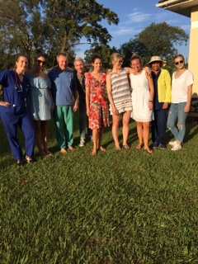
Volunteers outside the Guest House

Philip Unwin distributed knitted toys kindly made and donated by Jenny Squire from Henley. The children loved them.
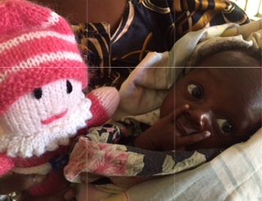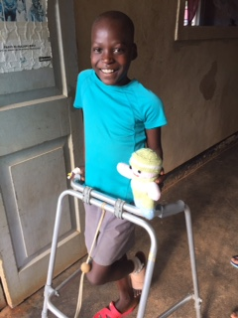

Completed Projects - The last payments were made on the Junior and Senior Staff Houses and these are now fully occupied. The Guest House has received well over thirty visitors since July this year, all wonderfully catered for and looked after by Gorret the housekeeper. All visitors contribute to the cost of the meals and make a small contribution to the hospital towards their stay at the Guest House.
A block of latrines has been built for visitors to the hospital and a chain link fence has been erected around the land the Guest House is built on. A vital new storm drain has also been completed.
We funded the purchase of several oxygen cylinders and regulators, and repaired a laboratory machine and a nebuliser.
Art Project - Collin Sekajugo a renowned visual artist came to the hospital with a team of four young artists to paint colourful murals on the hospital walls to help brighten up the very dark wards. The wonderful artwork was well received by both patients and staff. We hope you agree they look fantastic.
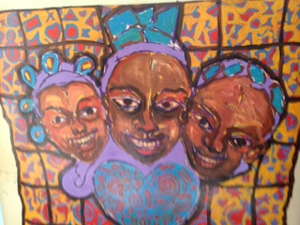
Mural in Maternity Ward
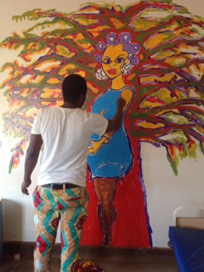
Collin Sekajugo the artist who led the project
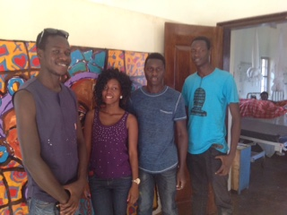
The team of artists who helped Collin
Ambulance Project - As many of you know Alice Unwin felt there was a great need to put in place an emergency transport facility for the people of Kamuli and the surrounding communities. We supported this vision and saw the need for this. Alice has spent the past year exploring the feasibility of this, the possible modes of transport as well as putting in place the infrastructure to maintain and run the service. We also consulted an expert in this area who undertook some due diligence. The conclusion is that it would be almost impossible to ensure that an emergency vehicle is kept fuelled and adequately maintained at all times. Further, it would be necessary to employ a coordinator/driver to determine who would be entitled to use the emergency vehicle, and funding for this would also need to be found.
These issues were discussed with the charity's Trustees who are responsible for ensuring that every penny given to KamuliFriends is spent effectively, and utilised for the purpose it was raised. After much discussion the Trustees agreed that the large capital outlay for the vehicle itself, which ultimately may not be adequately maintained and possibly left unused because of lack of funding for repairs and petrol, was not a good use of funding.
The Trustees have proposed (and Philip and Alice Unwin agree) that we ask the people who generously donated funds at the various ambulance fundraisers whether they would agree to the funds being diverted to other capital projects. If you have any objection to this proposal please contact Trudie Franklin on trudief@btinternet.com to let her know.
Anti-venom project - one of the visiting doctors is undertaking an anti venom project. Snake bites occur regularly here in Uganda and he is studying the effectiveness of giving anti-venom. KamuliFriends is sponsoring this work.
Proposed project plans for next three years
New Medical Ward. Our major priority is to replace the current 100 year old medical ward. There are holes in the ceilings, windows are broken and the medical ward building is crumbling. It is dark and conditions can be very cramped. There is an area which serves as an isolation ward but this is not really serving it's purpose as a purpose built isolation unit. The plan would be to have segregated male and female areas together with some isolation rooms where barrier nursing can be carried out.
Plans and a breakdown of costs are currently being drawn up for the Trustees to study and hopefully approve. Below are some pictures of the current Medical Ward. Even if we don't have all the money yet we have to get started, the Ward is appalling!

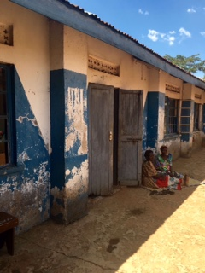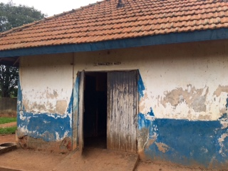
Pictures of the current medical ward which has holes in the roof and the building is crumbling.
New Paediatric Ward . Currently the paediatric ward is sited outside the hospital compound which is not ideal. The children have to travel some distance to the operating theatre and the x-ray department and are not under cover. The new paediatric ward would be attached as a wing on to the new medical ward.
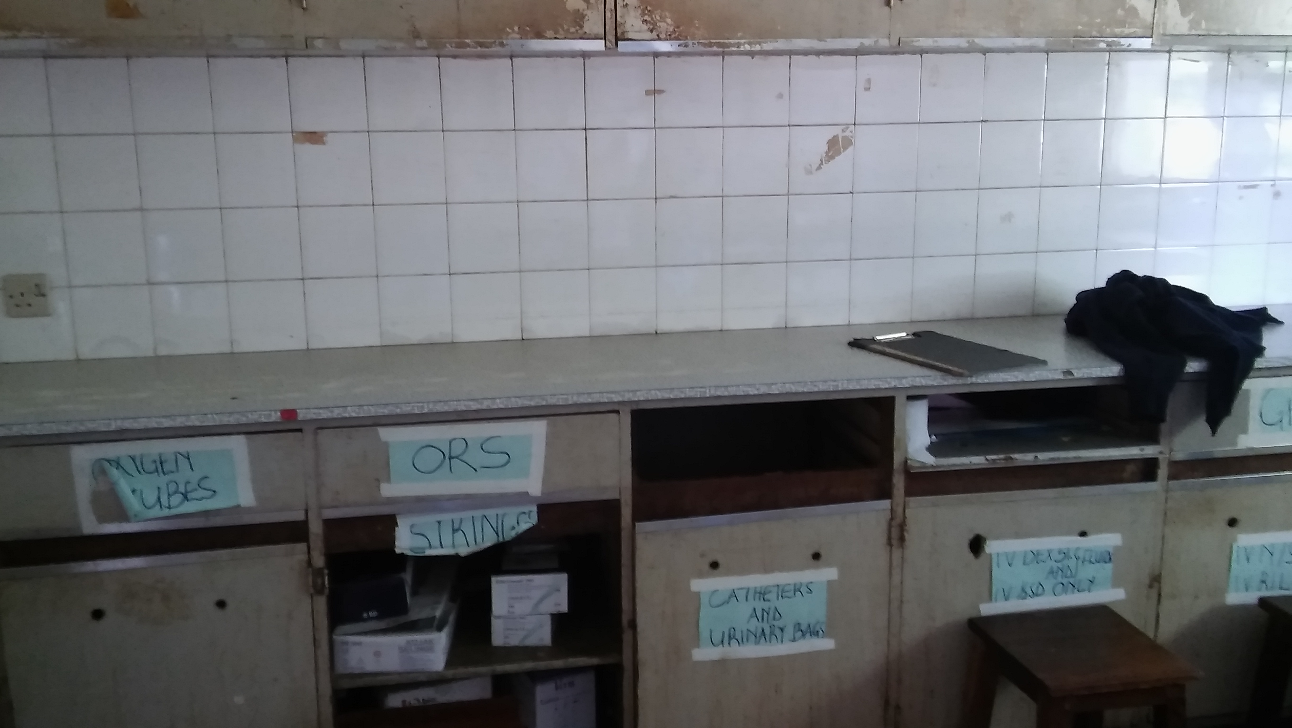
Inside the Paediatric Ward – Office
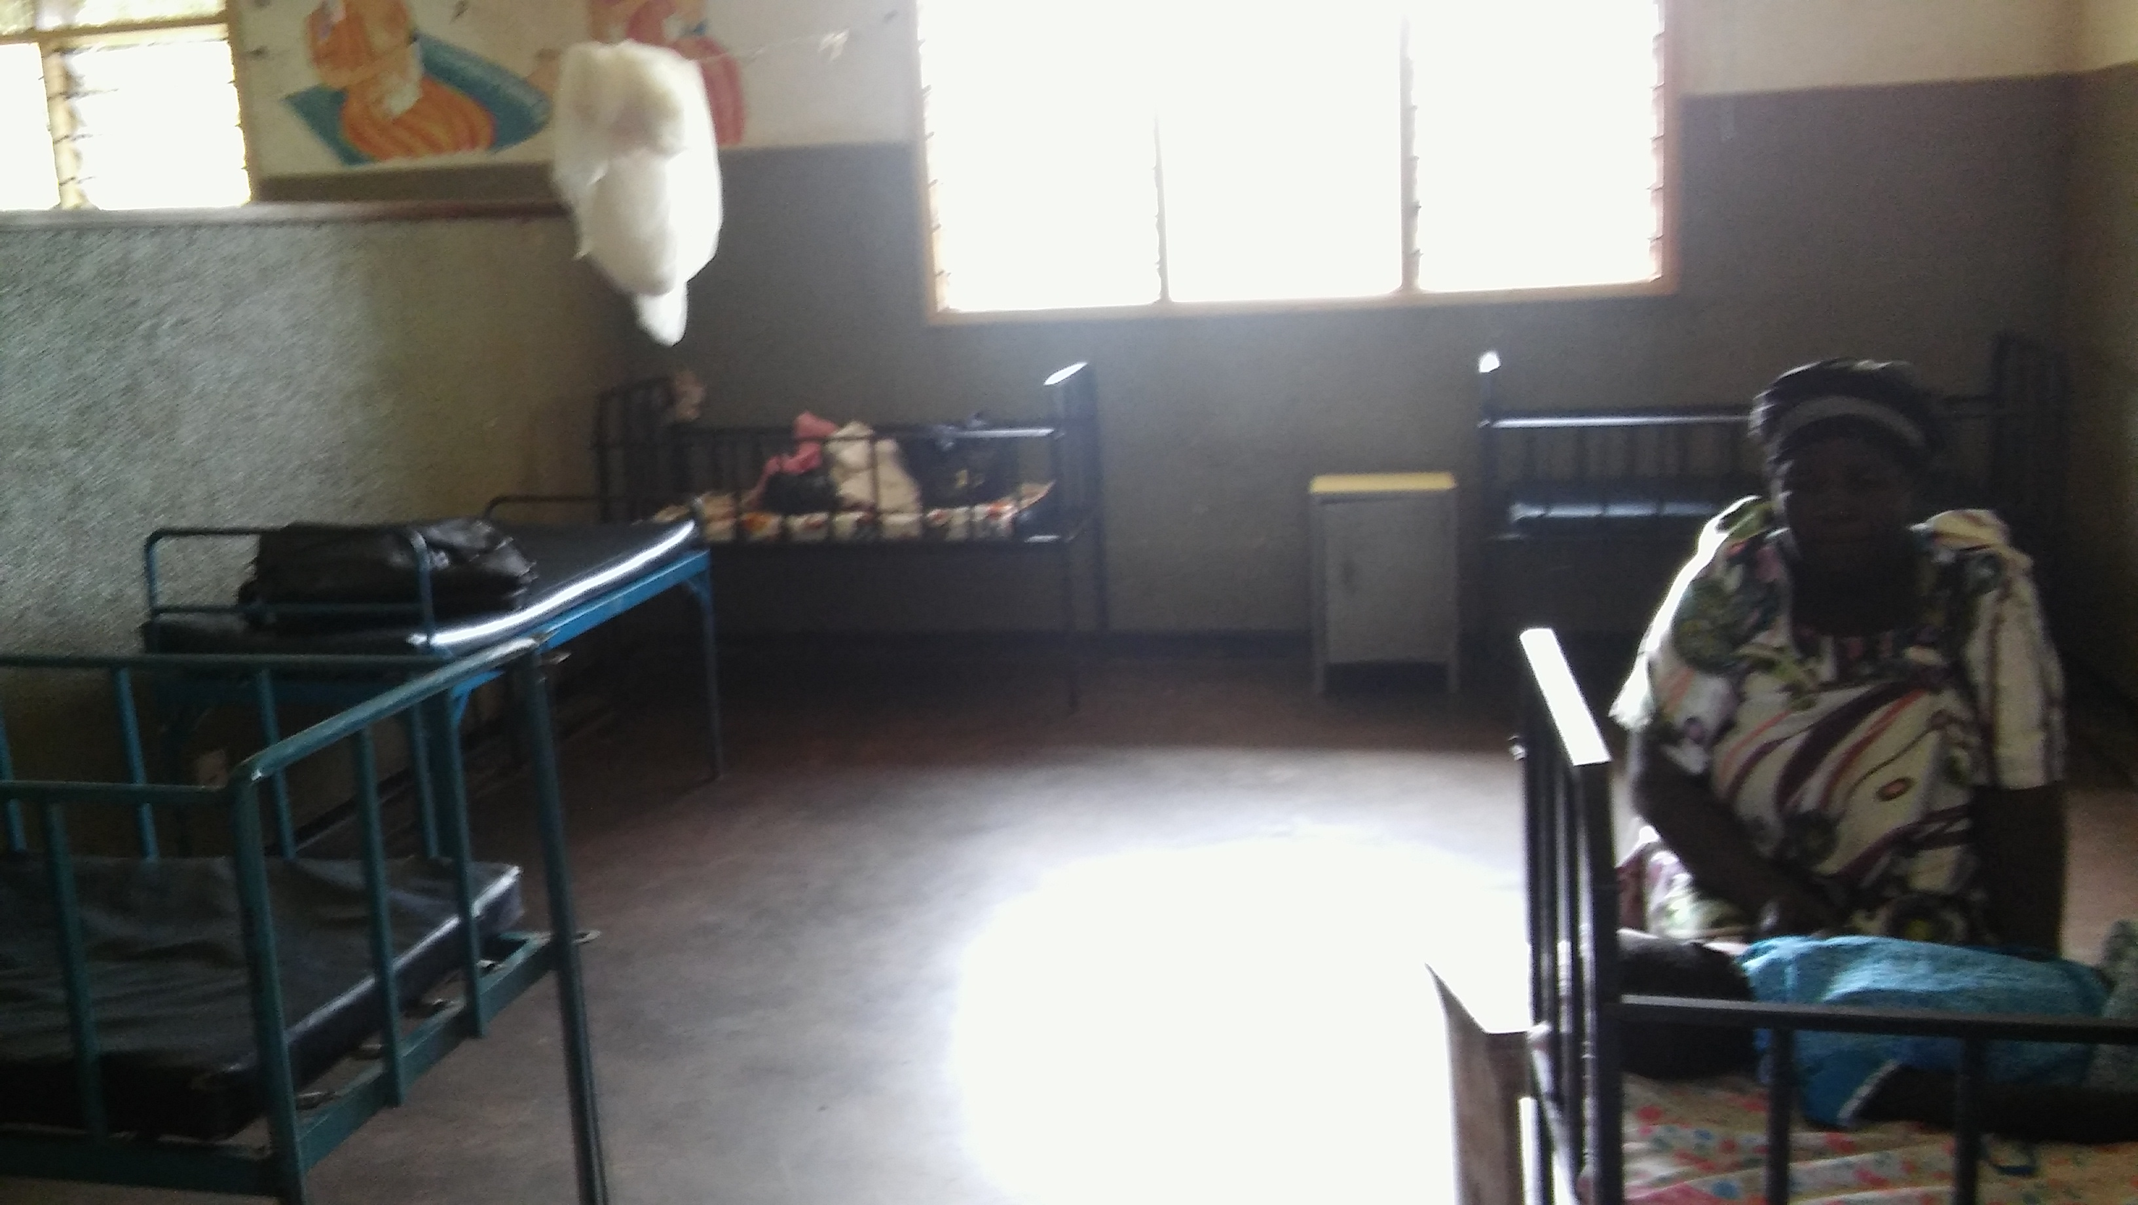
Inside the current Paediatric Ward – mother and child
The total cost for this extensive building work, both the new medical ward and the new paediatric ward, is £200,000 and it would take a year to build.
As you can see there is a lot to be done, and the only way the hospital will be able to improve its buildings is by outside funding. They have very little money and cannot afford to repair the smallest things at times e.g. Lab equipment. We will continue to strive to raise funds in order that we may help them and everything you have given is greatly appreciated by all the staff and patients at Kamuli Mission Hospital.
If you would like to know more about KamuliFriends visit our website www.kamulifriends.com or follow us on Instagram KamuliFriends.
With all best wishes for a happy and healthy 2017.
Philip, Alice, Fred, Steve, Trevor, Helen and Trudie
KamuliFriends
http://www.kamulifriends.com/
Registered Charity No1155812
Just Giving link (http://www.kamulifriends.com/donate/) click here

